The Leitrim Association of People with Disabilities Ltd
Station Road, Mohill, Co. Leitrim
Ph. 071 9651000 Fax 9651006 Email: lapwd04@eircom.net Website: www.lapwd.com
LAPWD promotes the philosophy of independent living, supporting the rights of people with a disability to exercise choice and enabling their full participation in society. It does this primarily through its personal assistant service, covering all parts of Co. Leitrim and West Cavan. Members can also avail of our accessible transport, advice and information and any social and recreational activities.
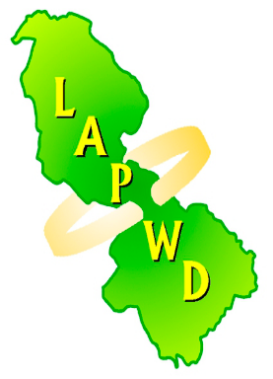
MEMBERSHIP FORM 2021
(please use block capitals)
€10.00

Name ---------------------------------------------------------------

Address -----------------------------------------------------------------------------------------------------------

Email Address ---------------------------------------------------------
Male/ Female □ Date of Birth----------------------------------------------------

Phone Number ---------------------------------- Mobile Number -------------------------------
I am a person with a disability □

Please state type of disability ----------------------------------------------------------------------------------
I am a Personal Assistant □ I am a Carer □
Person with an interest in disability □
Payment made by: Cheque □ Cash □
I am interested in volunteering for awareness or fundraising events during the year □
YOUR DATA WILL BE STORED ON LAPWD DATABASE. IF YOU DO NOT WISH US TO DO SO PLEASE TICK □

THIS INFORMATION IS TREATED CONFIDENTIALLY AND WILL NOT BE GIVEN TO ANY OTHER PARTIES

FOR OFFICE USE: DATE OF MEMBERSHIP RECEIVED ------------------------------------

