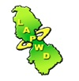
L.A.P.W.D
Annual
Run
Walk
Roll

Date: Sunday 21 May 2017
Time: Registration from 11.30am-12.30pm
Venue: Station Road, Mohill, Co. Leitrim
Contact: 0719651000 Charity No: 12005 Company No: 273863

